DATE : 22.02.2019
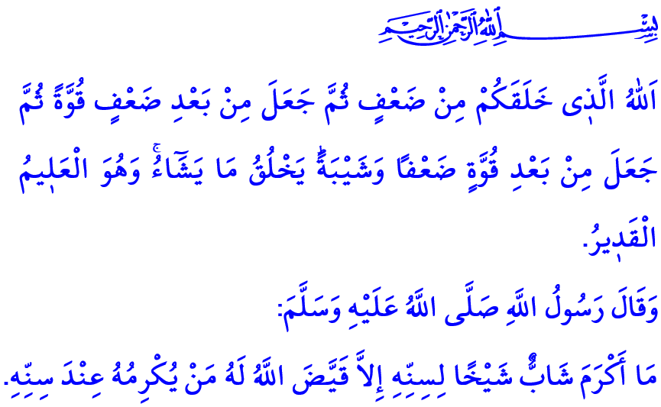
TAKING GOOD CARE OF THE ELDERLY MAKES LIFE BLESSED
Dear Muslims!
It was the day Makkah was conquered and the longing had come to an end when the Prophet Muhammad and his companions could return to their hometown from which they were exiled years ago. Muslims were all hugging each other with joy and relief, and thanking Allah for blessing them with such a day. As soon as they arrived in the city, the Prophet Muhammad’s loyal friend Abu Bakr went directly to his father. He had a great wish for his father to become a Muslim, so he took him to the Prophet Muhammad. Seeing Abu Bakr’s father Abu Quhafa, with his hair and beard gray and his eyes blinded due to the old age, the Prophet Muhammad, with his usual humble and respectful manner, said, “Would not it have been better if you had left him home and we had gone to him?”
Honorable Believers!
Life is much like the seasons in a year and has its spring, summer, fall, and winter. Every stage of life has its own niceties. Each is an opportunity for Muslims as servants of Allah to add meaning and value to life through good deeds, worshipping, and servitude to Him. The most valuable stage of life, during which people attain the pleasure of feeling mature and perfectness, is the old age stage. It is the stage of full of wisdom where the body is exhausted, but the soul is stronger than ever with experience acquired until then.
Honorable Muslims!
Allah particularly answers the prayers of the elderly, and offers blessings to them. They link the past to the future, handing down our national and immaterial values and culture to future generations. They are the pillars of our homes and the source of blessings. With their hair gray and their posture arched, they are sources of mercy and compassion for the society. There is no richer and better person than an elderly who has lived a life as aware of the value of health and years gone by, as expressed in the words of the Prophet Muhammad when they asked him about who the best person among people was, “…Whose life is long and his deeds are good.”
Dear Believers!
People are in constant need of keeping contact with their family and environment, and maintain relations with others. Such a need and dependency is felt even more during the old age. Excluding the elderly from the joy of life and from the society leads them to unhappiness and loneliness. On the other hand, the elderly who are respected, taken care of, and consulted to feel peaceful and secure, as well as they do not feel the distress of loneliness and abandonment.
Honorable Believers!
On top of people who deserve and need our care, love, and support come our parents, as expressed in the words of the Prophet Muhammad, “The Lord's pleasure is in the parent's pleasure, and the Lord's anger is in the parent's anger.” The compassion and affection that we will show to our parents are of particular importance in their old age when they need a peaceful home. To be by their side, to meet their needs, and to be prayed by them are among the most important opportunities for us to get the approval of Allah.
It is a grave act of disloyalty to leave and abandon one’s parents in their old age. In this respect, the Prophet Muhammad pointed to the misfortune of a person, who would not be able to enter the heaven because of not getting the approval of either of his/her parents in old age, “Let him be humbled into dust.”
Dear Muslims!
Being a reasonable person requires us to see the journey of our own life in those of the elderly. Just as yesterday’s young people are today’s elderly, today’s young people will be the elderly of tomorrow. In this respect, Allah says, “Allah is the one who created you from weakness, then made after weakness strength, then made after strength weakness and white hair. He creates what He wills, and He is the Knowing, the Competent.”
Then, let us take care of our old people who prepared us for life when we were young. Let us fulfill our responsibilities to make their lives easier, and let us benefit from their experiences. Let us not forget that respect for our elderly will bless our life. I would like to conclude my khutbah with the following hadith of the Prophet Muhammad, “No young person honors an elder due to his age, except that Allah appoints for him, one who will honor him at that age.”

Ibn Hanbal, VI, 350.
Tirmidhi, Zuhd, 21.
Tirmidhi, Birr, 3.
Muslim, Birr, 10.
Qur’an 30:54.
Tirmidhi, Birr, 75. General Directorate of Religious Services

